Dept. of Biomechatronics Engineering, National Taiwan University
Intelligent Control
Homework 4: Backpropagation Neural Network
(Turn in by group)
Page 1/1
Deadline: 14:00, April 13th

- The following figure shows the parameters of joints and links of a DOBOT robot
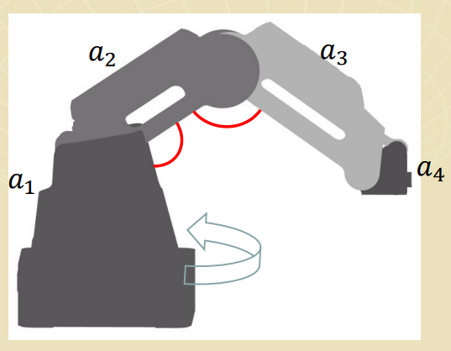
θ₁
θ₂
θ₃
Spatial relationship among axis joints and the position of the end effector
(Forward kinematics)
Joint angle → Position of
end effector
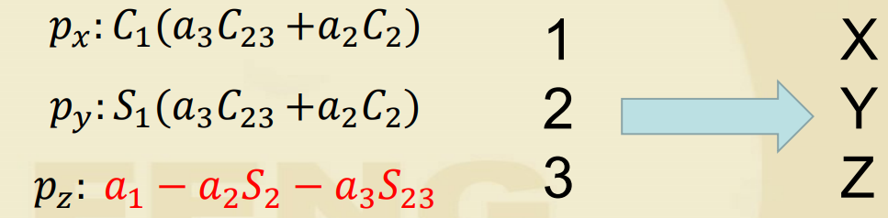
: Length of links
Using the following forward kinematics equations when you write your program
dx = C1 * (a3 * C23 + a2 * C2 + a4)
dy = S1 * (a3 * C23 + a2 * C2 + a4)
dz = -a2 * S2 - a3 * S23

a1 = 0
a2 = 135
a3 = 147
a4 = 61

C1 = np.cos(q1)
C2 = np.cos(q2)
C23 = np.cos(q2 + q3)
S1 = np.sin(q1)
S2 = np.sin(q2)
S23 = np.sin(q2 + q3)

- Build a inverse kinematics model by using Backpropagation neural network (BPNN) to solve θ₁, θ₂, θ₃ if X, Y, Z are given. The program of the model needs to be written in Python language and use the Pytorch package. You can refer to the attached python program but use the Tensorflow package
- Write a program to generate data for the training, validation and testing of the model building

- This is a six hump camelback function (as shown in the following) where both x and y lie between ± 5
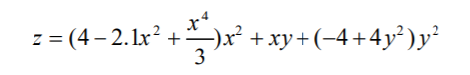
- Build a Backpropagation neural network (BPNN) program to approximate the six-hump camelback function. The program needs to be written in Python language and use the Pytorch package
- Write a program to generate data for the training, validation and testing of the function approximation

